General Specifications
- LED
  - 10.5 volts for LED’s in series (2 batteries)
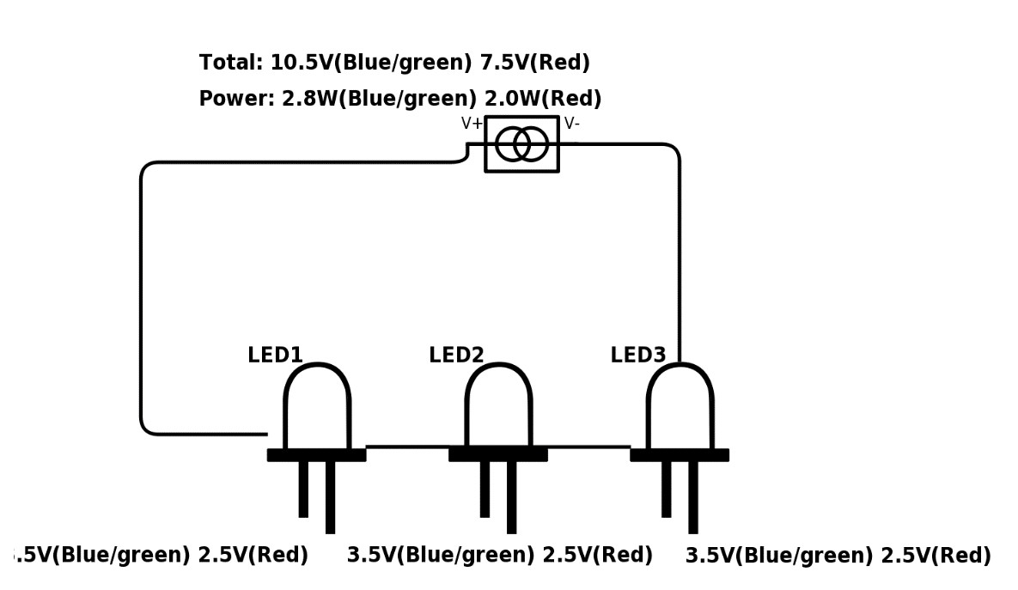
  - 3.5 volts for LED’s in parallel (1 Battery)
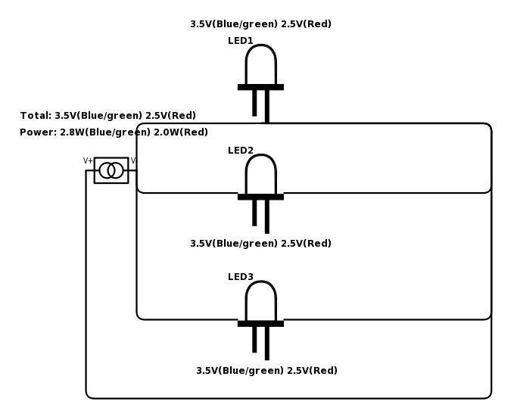
- LED Driver Circuit
  - Look into an external Clock (increase processing speed to 16MHz)
  - “Sleep” and “Wake-up” will be delegated to the Receiver chip and LED Driver Circuit

